NAMA : SILVIA SEPTIANI

KELAS : 19.3D.25

NIM : 19200481

# ***ModelBuku.php***

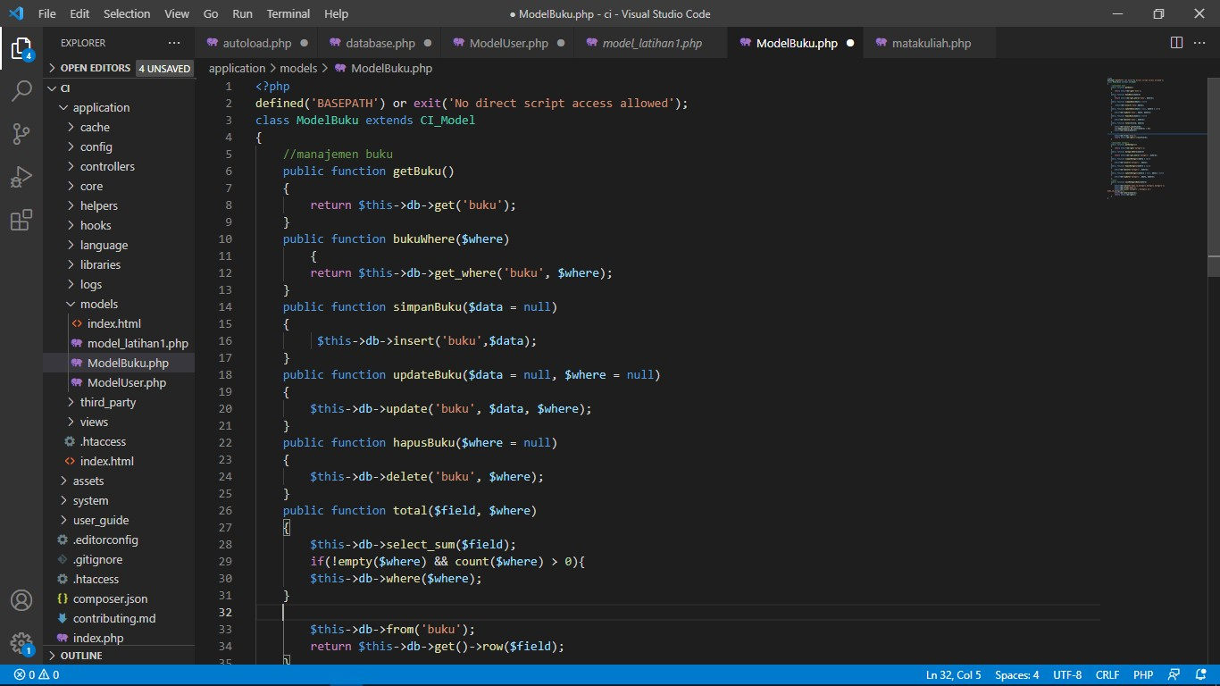

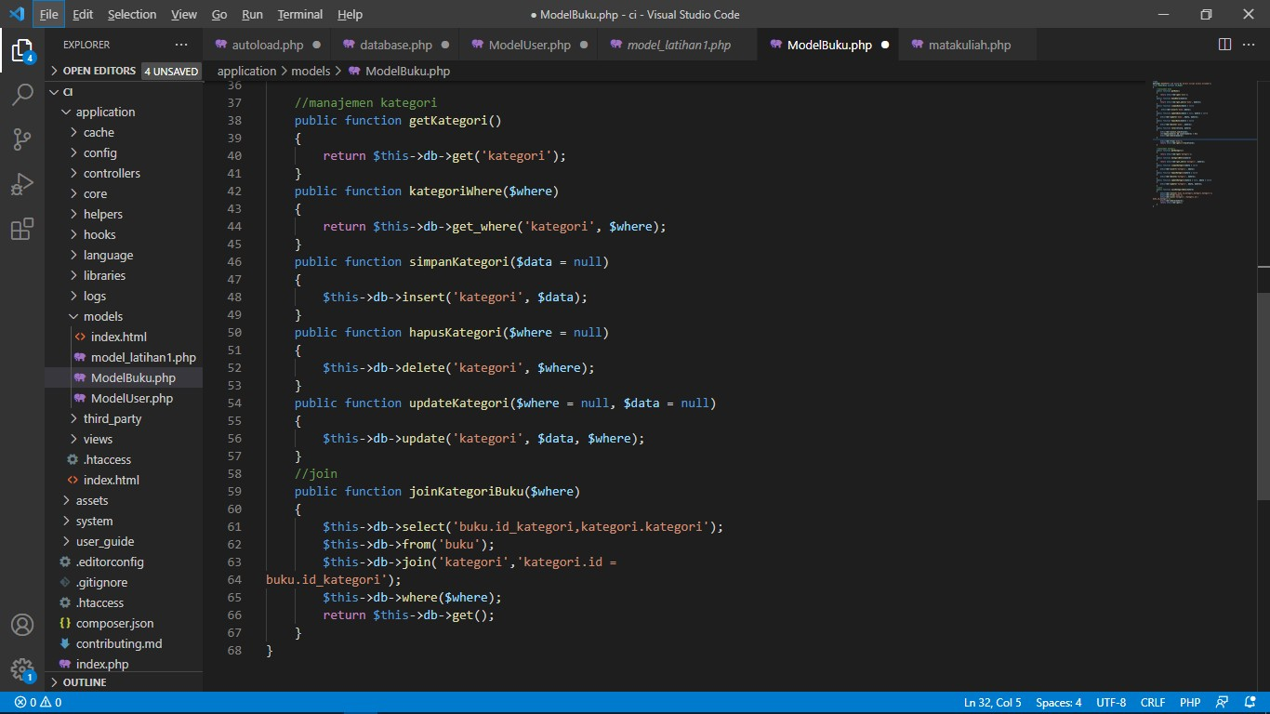

***ModelUser.php***

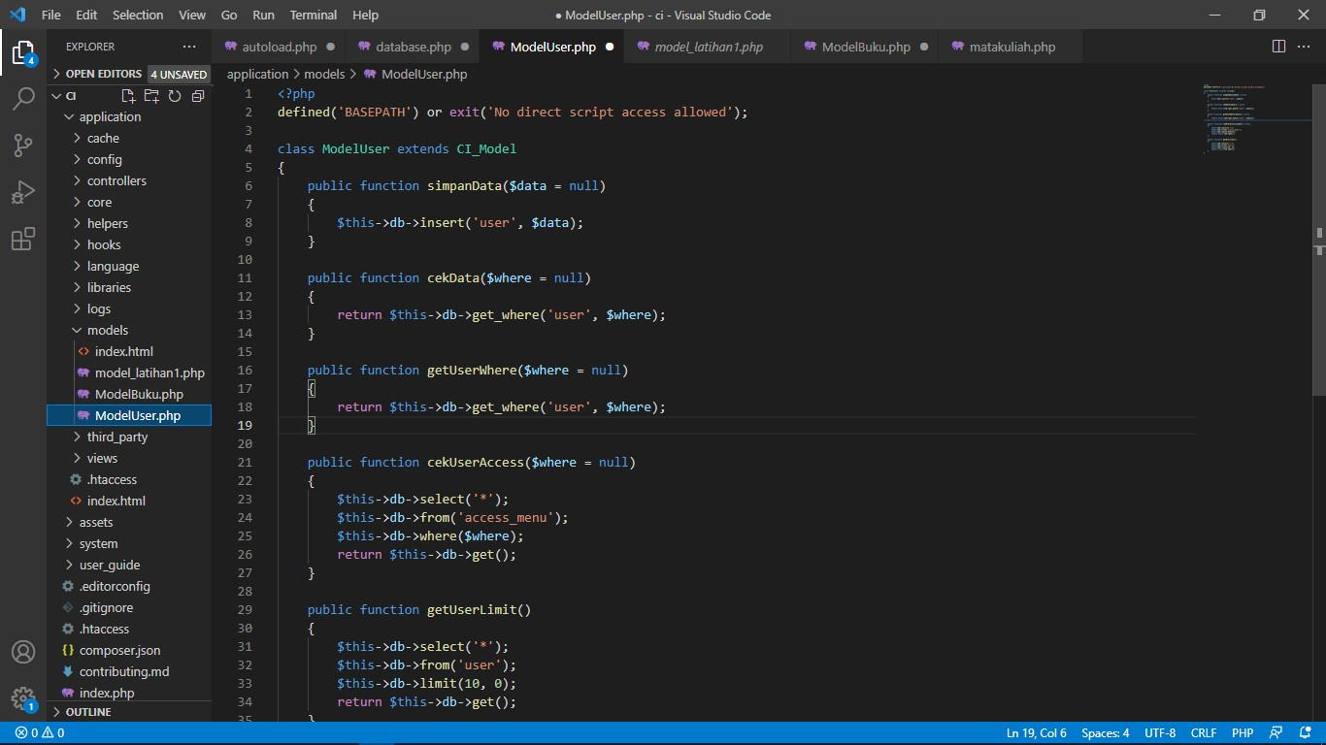

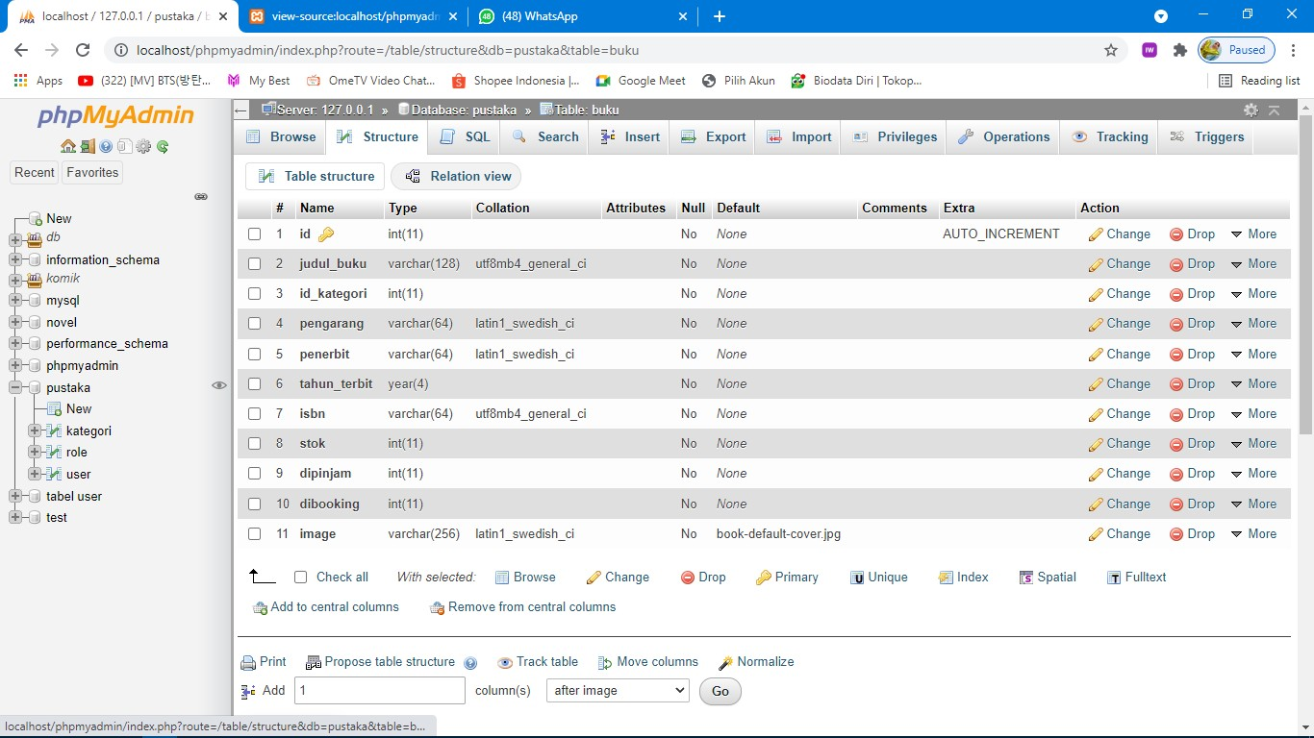***Table Buku***

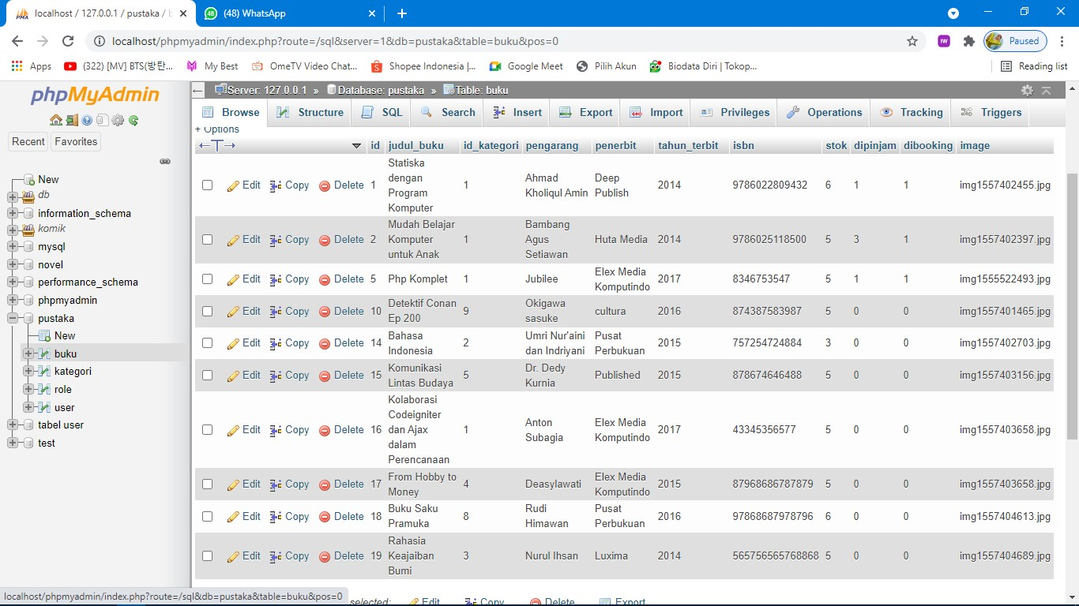

***Table Kategori***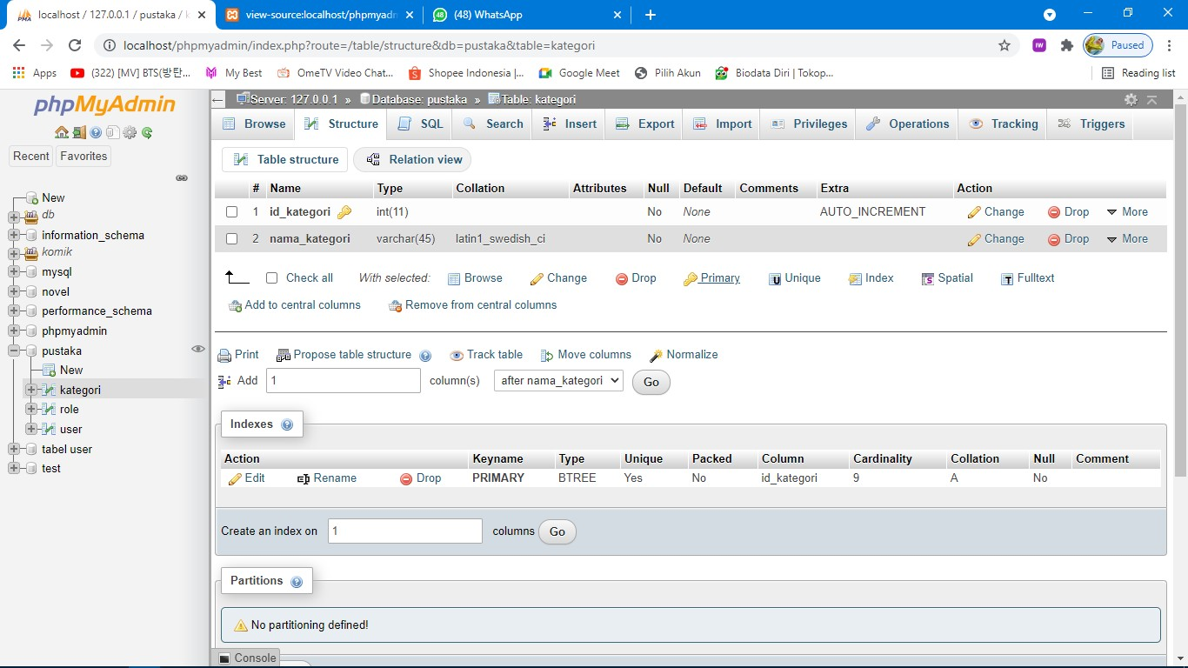

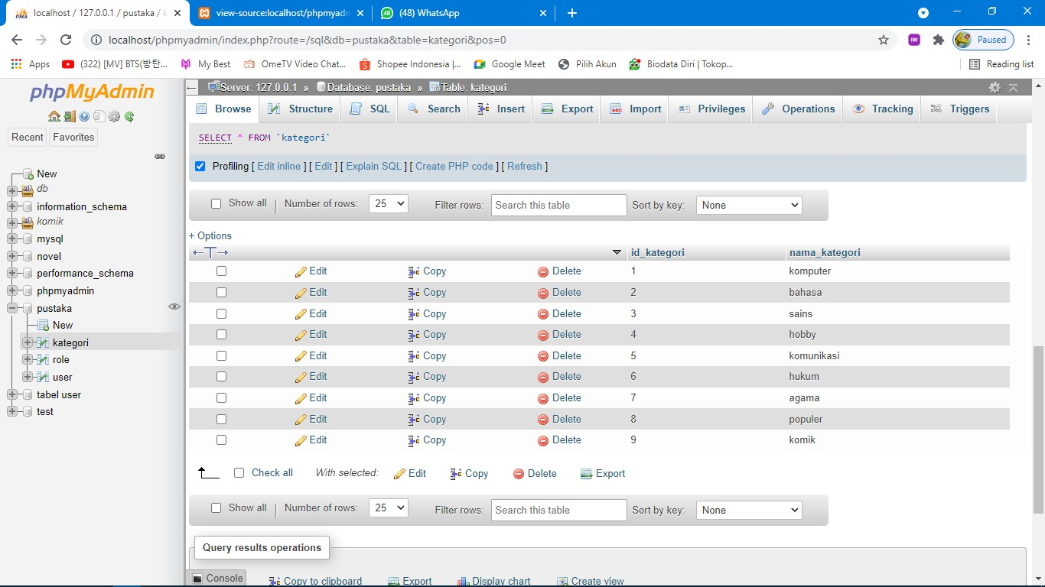

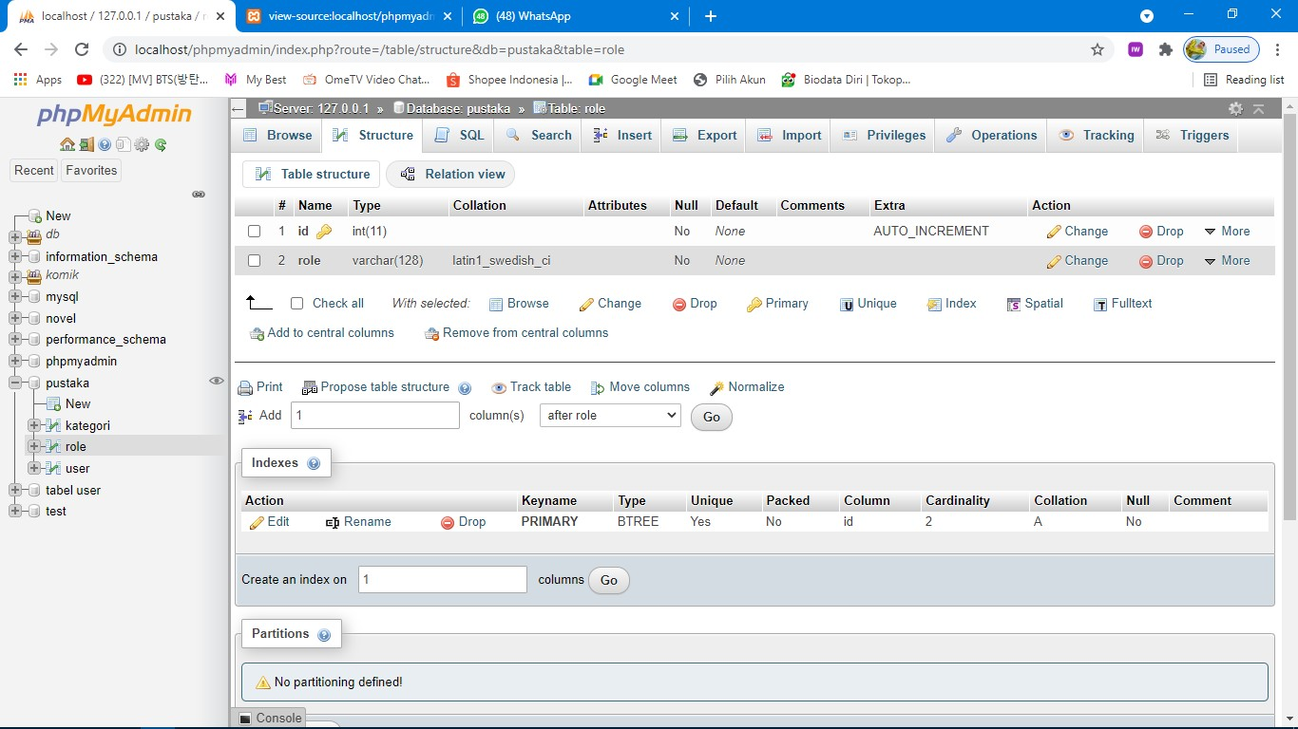***Table role***

*phpMyAdmin ” ' ' ' '*

 



* tn form a t1o n sched



 ° F4ter rows e I e Sort by key None •



 mem6 er

roie



+

Q Ohow aTT | Number of rows 25 ° F4ter rows e I e Sort by key None



@ PrTnI

j• Copy to cttpb oard @ Gp on

DTsptay chart

@ Creaie vTew

